TABLE OF CONTENTS
CHAPTER 1: INTRODUCTION 01-07
  - Purpose 02-03
  - Scope 04-05
  - Features 06-07
CHAPTER 2: 08-09
Work Done in Related Areas 08-09
CHAPTER 3: SYSTEM ANALYSIS 10-15
  - User Requirement 10-11
  - Hardware Requirements 12-13
14-15
  - Software Requirements
CHAPTER 4: SYSTEM DESIGN AND SPECIFICATIONS 16-22
  - High Level Design 16-18
16-17
    - Project Model
    - Flow Chart 18
  - Low Level Design 19-22
    - Process Specifications 19-20
    - Screen Shots 21-22
CHAPTER 5: CODING 23-27
Project Coding 23-27
CHAPTER 6: 28-29
Unit Testing 28-29
CHAPTER 7: 30-32
  - Conclusion and Limitations 30-31
  - References 32

INTRODUCTION
FeelTune is an innovative web-based music player designed to enhance the way users experience music by automatically selecting songs based on their current emotional state. In today’s busy and stressful life, people often struggle to find music that resonates with their mood. FeelTune solves this problem by using advanced facial recognition technology to detect emotions in real-time and recommend songs that align with the user’s feelings. This personalized approach makes it easier for users to relax, uplift their spirits, or enjoy moments of happiness through music, without manually searching or curating playlists.
The main goal of FeelTune is to provide a seamless, intuitive, and interactive platform where technology adapts to the user’s emotions. The system identifies moods such as happiness, sadness, anger, or calmness and automatically generates a playlist of songs suitable for that emotional state. This ensures that the music listening experience becomes immersive and emotionally connected. By intelligently combining music and mood, FeelTune helps users enhance their well-being, focus, or entertainment experience naturally and effortlessly.
The project is structured with multiple integrated modules to ensure smooth functionality. The Music Recommendation module selects songs from a categorized music library corresponding to the detected mood. The system also includes a Feedback module where users can provide input on song recommendations, allowing the platform to improve and better align with user preferences over time.
FeelTune is developed using Python for backend logic, OpenCV for facial emotion recognition, and HTML, CSS, and JavaScript for a responsive and visually appealing frontend. The platform is highly interactive and compatible across different devices, making it convenient for users to enjoy music anytime. Its simple interface ensures that users of all ages and technical backgrounds can use the system effortlessly.

PURPOSE

Truth Lens was built to satisfy the growing demand for automatic fact-checking tools.The more often false information is shared, the more public trust is lost in media sources, and informed discussions are hindered. Manual validity checks on news stories are extremely time-consuming. Thus, Truth Lens provides an automated mechanism whereby—against a given news claim or an article—it quickly predicts the likelihood of the content being real or fake and retrieves useful evidence from the web. By melding a fine-tuned BERT classifier with evidence retrieval, the tool helps users differentiate between authentic and fabricated news, promoting awareness and reducing misinformation in the digital space.

SCOPE

Truth Lens focuses on the verification of news in the English language. A user can input a headline, text excerpt, or URL, and the system returns a verdict—“Real” or “Fake”—along with relevant supporting sources. Analysis of multimedia elements like images or videos and deep social context is beyond the scope of this version. The application is designed as a beta release targeted at news organizations and fact-checkers and runs on Streamlit. Its PostgreSQL database on Supabase logs all verification activities, thus allowing developers or auditors to review and improve the system over time. The interface, in a nutshell, works by BERT inference, web evidence retrieval, semantic similarity analysis, and cloud-based data logging.

PRODUCT FEATURES
Truth Lens provides the following key features:
- BERT-based Classification: It classifies the input text as real or fake using a transformer model fine-tuned on fake news datasets. Previous research, such as FakeBERT, demonstrates that BERT-based models can reach up to 98.9% accuracy.
- Evidence Retrieval: Utilizes the Google Custom Search API to find news articles or fact-check pages that support or refute the claim. The system has access to recent and diverse online sources.
- Semantic Matching: It employs fuzzy string matching via FuzzyWuzzy in order to match the user's input against retrieved evidence snippets and provides similarity scores that reinforce the classification decisions.
- User-Friendly Web Interface: A Streamlit-based UI for pasting text or a URL and immediately obtaining results (verdict and evidence links) is ideal. Streamlit’s ease of use makes it an excellent choice for quick machine learning prototypes.
- Comprehensive Logging: Every verification, including user input, label, evidence URLs, and confidence scores, is logged in a PostgreSQL database on Supabase. This increases traceability and supports model refinement in an iterative way.
- Real-Time Processing: Carries out the inference and search for evidence in real time, returning near-instant fact-checking results. This architecture balances accuracy and computational efficiency. Full-text approaches are resource-intensive.
Taken together, these features position Truth Lens as both practical and highly effective in digital news verification. It achieves top-tier accuracy on par with other state-of-the-art models but offers human-readable, verifiable evidence to explain each result.

WORKS DONE IN THE RELATED AREA

Nie et al. (2019) – Combining Fact Extraction and Verification with Neural Semantic Matching Networks:
This work described a fact-checking pipeline for the FEVER dataset, where neural semantic matching was performed in both document retrieval and claim verification. Their model achieved leading performance by jointly optimizing retrieval and entailment, demonstrating the power of deep semantic matching for factual verification.

Kaliyar et al. (2021) – FakeBERT: Fake news detection in social media with a BERT-based deep learning approach:
The paper introduced a hybrid BERT+CNN model for fake news detection. This model integrates parallel 1D-CNN layers with BERT representations. The system achieved 98.9% accuracy on benchmark datasets, emphasizing the strength of BERT-based architectures for this application.

Dhiman et al. (2024) – GBERT: A hybrid deep learning model based on GPT-BERT for fake news detection:
GBERT combined BERT with a GPT-based module into a hybrid model that achieved 95.3% accuracy. The study showed that transformer-based models can be effectively adapted for dependable fake news classification.

Zhao et al. (2024) – Knowledge-Guided Semantic Analysis for Fake News Detection:
This study developed an architecture that merged external knowledge graphs and semantic analysis to align text with known facts. A dual-branch network detected inconsistencies, improving accuracy through knowledge-grounded comparisons.

Cao et al. (2024) – Is Less Really More? Fake News Detection with Limited Information:
This research discussed inefficiencies of full-text approaches and proposed the “SLIM” framework, which focuses on essential information for detection. It highlighted how full-text models can be slow and require vast datasets, calling for leaner, more efficient methods.

Lee et al. (2023) – OE-Fact: Evidence-based Interpretable Open-domain Fact-Checking with LLMs:
This system uses Google Custom Search to collect potential evidence and applies neural filtering to isolate the most relevant facts. It demonstrates how combining search-based retrieval with language models can effectively automate open-domain fact-checking.

Each of these studies contributes to the foundational ideas behind Truth Lens—transformer-based classification, evidence retrieval, semantic matching, and computational efficiency. Truth Lens brings these achievements together in a unique, integrated web-based solution.
- SYSTEM ANALYSIS

USER REQUIREMENT

Flexibility in Input: The system should allow users to provide news content either by pasting text or entering a URL linked to an article or social media post.
• Real-Time Feedback: It should generate responses within 5 seconds, indicating whether the content is likely real or fake.
• Evidence Presentation: The application must display relevant evidence supporting the classification verdict, including titles, snippets, or fact-check URLs.
• Ease of Use: The interface should be intuitive and simple enough for non-technical users to navigate easily.
• Logging and Review: The system should enable administrators or users to review previous verifications stored in the database for auditing or troubleshooting purposes.

3.2 HARDWARE REQUIREMENT
• Development/Deployment Machine: A standard PC or server setup is adequate for model inference. A multi-core CPU is required, and a GPU (such as NVIDIA) is recommended for faster BERT inference or retraining.
• Memory: A minimum of 8 GB RAM is needed, with 16 GB preferred for handling model loading and processing.
• Internet Access: Required for making Google API calls and connecting to the Supabase database.
• Mobile/Desktop Compatibility: The Streamlit application should function across all modern browsers, although initial testing is done on desktop

SOFTWARE REQUIREMENTS

• Python 3.x: The primary programming language for development.
• Streamlit: Used to build the web interface; Streamlit documentation provides guidance for integration with Supabase and PostgreSQL.
• Machine Learning Libraries: Includes Hugging Face Transformers for BERT, with PyTorch or TensorFlow as the backend, and Scikit-learn for auxiliary processes.
• FuzzyWuzzy (or TheFuzz): Used for comparing string similarity scores.
• Google Custom Search API: Manages evidence retrieval queries and requires an API key.
• Database: PostgreSQL via Supabase. Database operations and log insertion can be handled with either psycopg2 or the Supabase Python client. Supabase serves as an open-source alternative to Firebase.
• Requirements File: A requirements.txt file should list all necessary dependencies (e.g., streamlit, transformers, fuzzywuzzy, psycopg2) to ensure uniform deployment across environments.

SYSTEM DESIGN & SPECIFICATION
  - HIGH LEVEL DESIGN(HLD)
Truth Lens follows a modular architecture consisting of four major components: the Streamlit front-end, the BERT inference engine, the evidence retrieval module, and the Supabase database backend.
The process begins when a user inputs a news claim through the web interface. The text is sent to the BERT classifier to predict whether the claim is real or fake. At the same time, a query is made to the Google Custom Search API to gather relevant online articles. Retrieved snippets are then compared to the original claim using fuzzy matching to evaluate their relevance.
The final output includes the verdict, confidence score, and evidence links. All data, including inputs and results, are stored in the Supabase PostgreSQL database for logging and analysis.
This modular design allows each component—UI, model, search, and database—to be updated or scaled independently.
4.1.1 PROJECT MODEL
The project adopts an iterative, Agile development model. Features were added in stages—starting with the UI and basic model inference, then integrating evidence search and fuzzy matching, and finally implementing database logging. This step-by-step approach allowed for continuous testing, feedback, and system improvements, ensuring smooth integration across Streamlit, Google API, and Supabase modules.

4.1.2 FLOW CHART

User Request: The user submits text or a URL through the Streamlit interface.

Claim Extraction: If a URL is given, the system scrapes its content.

ML Inference: The BERT classifier analyzes the text and predicts “Real” or “Fake” with a confidence score.

Evidence Retrieval: The system queries the Google Custom Search API using key phrases from the claim.

Result Ranking: Titles, snippets, and URLs from search results are retrieved and ranked.

Semantic Matching: FuzzyWuzzy compares the claim with each snippet to calculate similarity scores and selects the best matches.

Decision Output: The verdict, confidence level, and top evidence links/snippets are displayed to the user.

Database Logging: All results (claim, label, confidence, evidence data, and timestamp) are stored in Supabase.

If any module fails (e.g., due to API or connection issues), the system displays clear error messages and logs the event for troubleshooting.

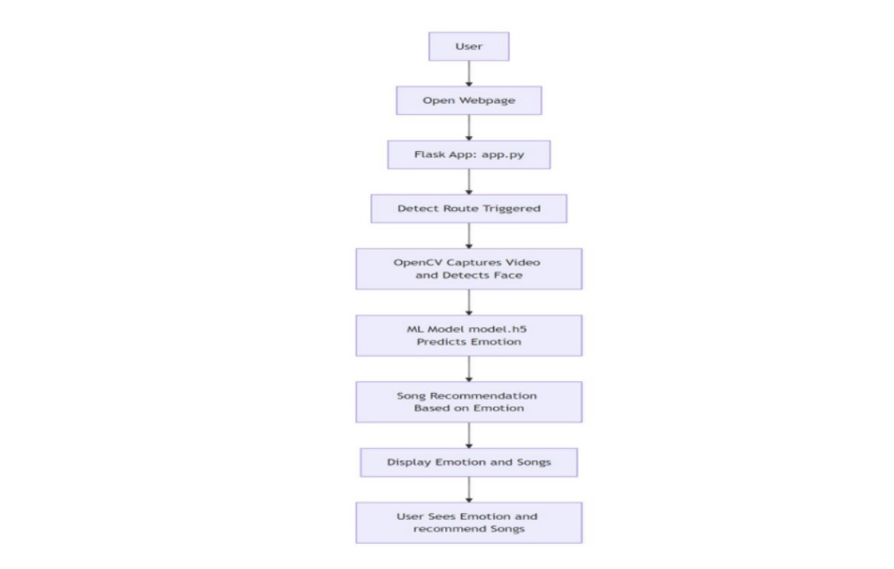
4.1.3 ER DIAGRAM
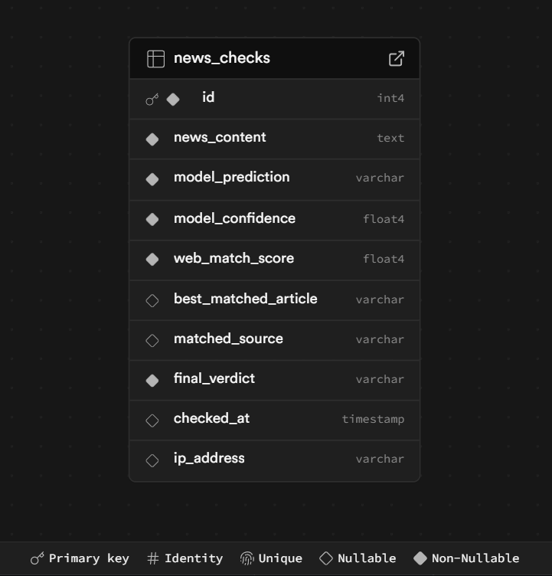

4.2 LOW LEVEL DESIGN(LLD)

4.2.1 PROCESS SPECIFICATIONS
Text Classification:
- Load the pre-trained BERT model during app initialization.
- Tokenize the input and run inference to generate probabilities for “Real” or “Fake.”
- Output the label with the higher probability.
Evidence Search:
- Create a search query using key terms from the claim.
- Send the query via the Google Custom Search API.
- Parse JSON results to extract article titles, snippets, and URLs.
Fuzzy Matching:
- Compare the claim text with snippets using FuzzyWuzzy:
- from fuzzywuzzy import fuzz
- score = fuzz.token_sort_ratio(claim_text, snippet_text)
- Select snippets above a threshold (e.g., 60%) as relevant and rank them by score.
Database Logging:
- Connect securely to Supabase PostgreSQL using credentials stored in Streamlit secrets.
- Insert a record into the Verification table with the claim, verdict, confidence, and timestamp.
- Insert related evidence records with URLs, snippets, and match scores.
- Commit the transaction and handle errors such as connection failures or timeouts gracefully.

SCREEN-SHOTS



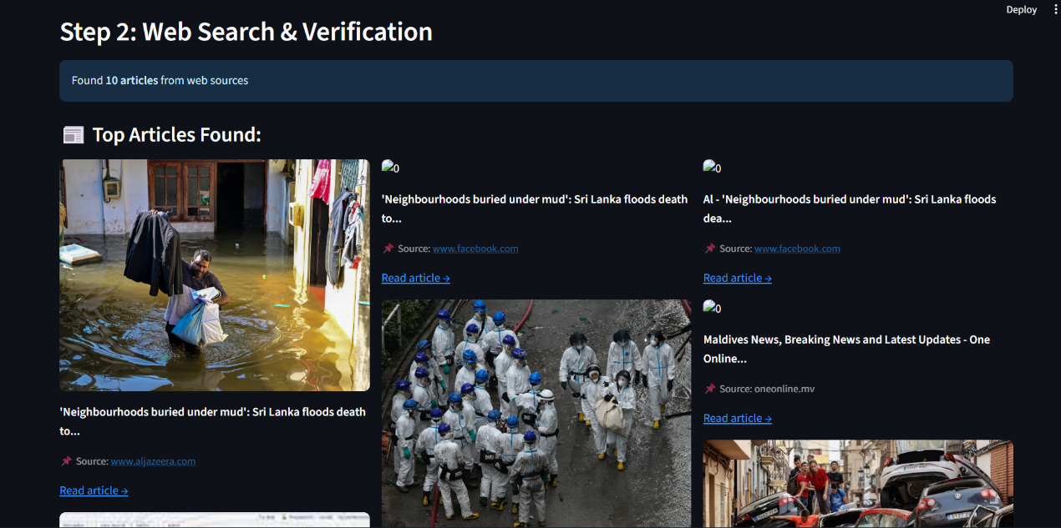
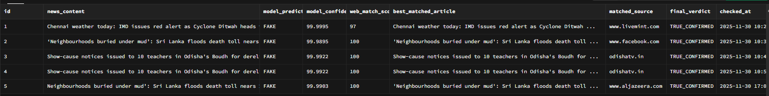

CODING
The codebase is divided into several modules to maintain modularity, ensure easy testing, and simplify long-term maintenance.
Main Files and Functions:
- app.py – Streamlit Front-end:
This file manages the web interface. It handles user inputs (text or URL), displays classification results and related evidence, and connects the UI with backend components. It also initializes the BERT model and database connections.
- classifier.py:
Loads the fine-tuned BERT model (e.g., using transformers.AutoModelForSequenceClassification) along with the tokenizer. It includes the function predict_claim(text), which outputs both a label (real/fake) and a confidence score. The module also covers input text preprocessing and postprocessing steps.
- evidence_search.py:
Implements the evidence retrieval logic. The function search_google(query) sends a request to the Google Custom Search API and retrieves a list of top results containing titles, snippets, and URLs.
- matcher.py:
Manages fuzzy string matching between the claim and the retrieved evidence. The function match_evidence(claim, snippets) calculates similarity scores using FuzzyWuzzy and filters relevant matches.
- db_logger.py:
Handles all database operations such as inserting verification records and associated evidence into Supabase (PostgreSQL). The function log_verification(claim, label, confidence, evidence_list) performs these insertions and ensures that transactions remain consistent.
- requirements.txt:
Lists all Python dependencies needed for deployment consistency—streamlit, transformers, torch or tensorflow, fuzzywuzzy, requests, psycopg2, and others.
- Helper Scripts:
May include additional utilities such as scrape.py (used to extract text from URLs) or utils.py (for shared functions).
Each module is thoroughly documented, outlining its purpose, inputs, and outputs. For instance, the predict_claim() function is unit-tested to handle edge cases like empty or very short inputs. The project adheres to best coding practices—modular design, structured exception handling, and meaningful comments—to ensure both readability and long-term maintainability.

UNIT TESTING
Classifier Tests:
Known Fake News: Provide an obviously false statement (e.g., “We have proof that aliens control world governments”) and confirm that the model classifies it as “Fake” with high confidence.
Known Real News: Provide a factual statement (e.g., “The Earth orbits the Sun”) and confirm that the output is “Real.”
Blank Input: Verify that the model handles empty or whitespace inputs gracefully, returning an appropriate message or “Uncertain” label.
Evidence Search Tests:
Valid Query: Provide a realistic news claim and ensure that search_google() returns a non-empty list of results.
No Results Scenario: Use nonsensical or obscure queries to confirm that the system handles zero results without throwing errors.
Fuzzy Matching Tests:
Identical Texts: When the claim and snippet are identical, the match score should be 100%.
Completely Different: If the texts are unrelated, the similarity score should be below 50%.
Partial Overlap: For example, the claim “Paris is the capital of France” compared to the snippet “France’s capital city is Paris” should yield a high similarity score, close to 100%.
Database Logging Tests:
Insert Verification: Insert dummy records and confirm that they appear correctly in the PostgreSQL table.
Foreign Key Integrity: Attempt to insert evidence with an invalid VerificationID and verify that the database rejects the operation.
Remedial Actions:
If any tests fail, corrective steps include checking model preprocessing, retraining with improved datasets, adjusting fuzzy matching thresholds, or refining API handling logic.
For API quota or timeout issues, caching and exponential backoff strategies are applied. Database-related errors are resolved by verifying schema integrity and retrying connections. After fixes, all affected tests are re-run to ensure stability and consistent performance.

CONCLUSION AND LIMITATIONS
Truth Lens successfully combines advanced NLP techniques with web-based information retrieval to effectively detect and verify fake news. The BERT-based classifier demonstrates strong baseline accuracy, and its integration with real-time evidence retrieval improves both transparency and interpretability of results. Logging via Supabase further supports auditing, monitoring, and iterative enhancement of the system. Overall, this project showcases how transformer-based models, when paired with online search mechanisms, can automate the process of fact-checking.
Limitations:
- Model Dependency: The accuracy of the system depends heavily on the quality and diversity of its training data. Since it analyzes only textual information, it might misclassify content requiring deeper context, sarcasm detection, or domain-specific understanding.
- Limited Scope: At present, the tool supports only English text and excludes multimedia (images, videos) or social metadata, all of which can play key roles in identifying misinformation.
- Search Noise: Evidence gathered from Google may include irrelevant, duplicate, or low-quality sources that occasionally distort the final decision.
- External Dependency: The reliance on third-party services such as Google Custom Search and Supabase introduces vulnerabilities related to network issues, API limits, or policy changes.
- Computational Overhead: While efficient, BERT inference can still be resource-intensive, potentially limiting scalability on lower-end hardware.
Future Enhancements:
- Add multilingual support for broader applicability.
- Introduce credibility scoring for retrieved sources to enhance reliability.
- Explore domain-specific fact-checking APIs and knowledge graph integration.
- Optimize model performance for faster inference without compromising accuracy.
- Incorporate social media metadata and image analysis to provide richer context.
In conclusion, Truth Lens forms a solid and practical foundation for automated fake news detection. Despite its current limitations, it lays the groundwork for future systems capable of deeper AI reasoning, integrated knowledge access, and dynamic real-world evidence retrieval—fostering a more trustworthy digital information environment.

REFERENCES

- Alpha Iterations. (2024). Fuzzy Matching with FuzzyWuzzy: A Comprehensive Guide. Medium.
- Amazon Web Services. (2023). Harness Large Language Models in Fake News Detection. AWS Machine Learning Blog.
- Cao, Z., Nguyen, J., & Zafarani, R. (2024). Is Less Really More? Fake News Detection with Limited Information. In Proceedings of the AAAI Conference on Artificial Intelligence.
- Dhiman, P., Kaur, A., Gupta, D., Juneja, S., Nauman, A., & Muhammad, G. (2024). GBERT: A Hybrid Deep Learning Model Based on GPT-BERT for Fake News Detection. SN Computer Science, 5(1), 120.
- Kaliyar, R.K., Goswami, A., & Narang, P. (2021). FakeBERT: Fake News Detection in Social Media with a BERT-Based Deep Learning Approach. Multimedia Tools and Applications, 80(8), 11765–11788.
- Nie, Y., Chen, H., & Bansal, M. (2019). Combining Fact Extraction and Verification with Neural Semantic Matching Networks. In Proceedings of the AAAI Conference on Artificial Intelligence (AAAI).
- Zhao, W., He, P., Zeng, Z., & Xu, X. (2024). Fake News Detection Based on Knowledge-Guided Semantic Analysis. Electronics (MDPI), 13(2), 259.

